

**National University of Computer & Emerging Sciences, Karachi Campus**

CS217-Object Oriented Programming

Department of Computer Science

**PROJECT REPORT**

**FOOD DELIVEROO**

**Group Members:**

Abdul Bari 19K-0264

Ariba 19K-0252

BSCS - A

**0. Acknowledgment**

I am grateful to few sources that supported us throughout the project. Primarily, I thank Sir Basit, Saurabh Shukla and Stack Overflow for helping us complete this project.

**1. Introduction**

Basically, this project will facilitate people by delivering them food in the shortest possible time, and a variety of restaurants, online. There are 3 user ends, customer, restaurant and admin. Each user must enter the system with their authentic and unique ID and password.

Moreover, this system will provide a platform for online food orders to the customers, where they would be having additional benefits of coupons and delivery notifications time to time. Customer has to rate the restaurant after the order is completed.

The main control of the system will be in the hands of admin. Admin can check each restaurant’s ratings, earned profit and can remove any restaurant from the system as per its will. Also, he can add or delete coupons that are offered to the customers. The restaurants hold the authority to make changes (add, update and delete) to their respective meals and deals. They can check their ratings.

**2. Tools and technologies used**

A list of all tools that are indulged in our project:

1. Visual Studio Code
2. Notepad

**3. Class diagram**

**UNIFIED MODELING LANGUAGE**

+ AddCoupen(): void

+ deleteCoupen(): void

+ ViewAllCoupens(): void

+ ViewRestaurantsRating(): void

+ Profit(): void

+ ProfitFile(): void

+ CustomerDetails(): void

+ OrderDetails(): void

+ KickOut(): void

- AllRestaurants (): void

- AdminManagment (): void

- Login (): void

+ getLogin(): void

ADMIN

- amount: double

**CUSTOMER**

#user_name:char[]

#password: char[]

#Phone_Num: int

#address: string

#un: char[]

#p: char[]

#flag: int

+SetCustomerData(): void

+getname(): char*

+getpass(): char*

+getun(): char*

+getp(): char*

+LoginCustomer (): void

GLOBAL

ChooseCategory (): void

**RESTAURANT**

# coupen: char[]

# coupen_price: double

# total: double static

# rating: int

- item_size: char[]

- item_name: char[]

- item_price: double

- item_code: int

- comment :char[]

- count: int

- sumofrating: double

- avgRating: double

- countplaceorder: int static

+ InputData () :void

+ getData () :void

+ showRecord () :void

+ ViewAllRecords () : void

+ updateRecord () :void

+ deleteRecord () :void

+ PlaceOrder (): void

+ CalculateBill ():void

+ CalculateProfit (): void

+ Rating () :void

+ ShowRating () :void

+ DeliveryNotification (): void

**ADMIN**

- amount: double

+ AddCoupen(): void

+ deleteCoupen(): void

+ ViewAllCoupens(): void

+ ViewRestaurantsRating(): void

+ Profit(): void

+ ProfitFile(): void

+ CustomerDetails(): void

+ OrderDetails(): void

+ KickOut(): void

- AllRestaurants (): void

- AdminManagment (): void

- Login (): void

+ getLogin(): void

Data flow diagram

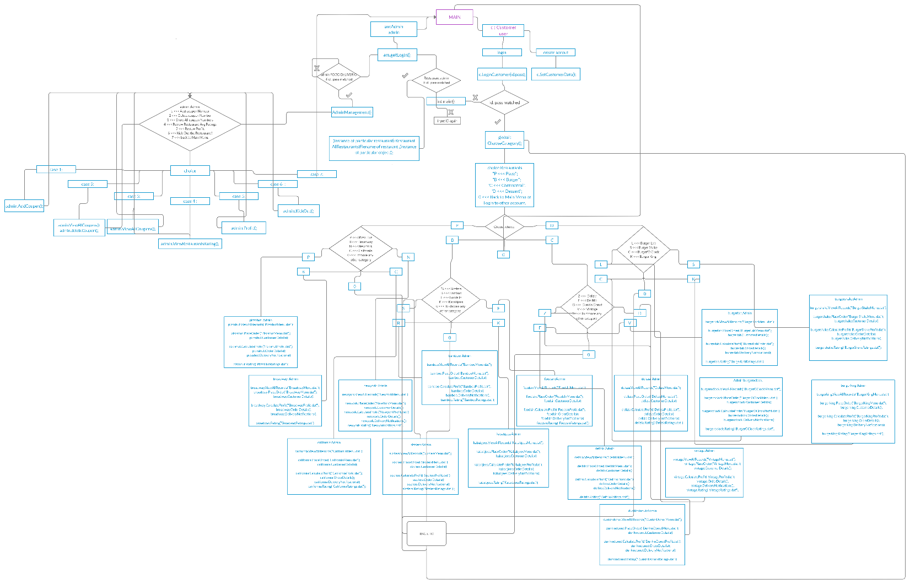

1. **Link to source**

<https://drive.google.com/file/d/16u_PYjx7oX5BbNzDUjqzR_T3Z3R5nupX/view?usp=sharing>

1. **Conclusion**

Lastly, we could have made this system GUI based, but due to time constraints and c++ limitations we didn't. We would have introduced an option for the admin to add new restaurants to the system as well. Putting all of our efforts, we anticipate that this application is of some use to the businesses like food panda.